Steps to check allocation details before entering time in clarity
- Login in I-connect and click on the Employee Management group.
OR You can directly use the link as https://orts.fs.capgemini.com, this will redirect you to the SSO authentication. By putting username and password, you can login in ISW/IRW.
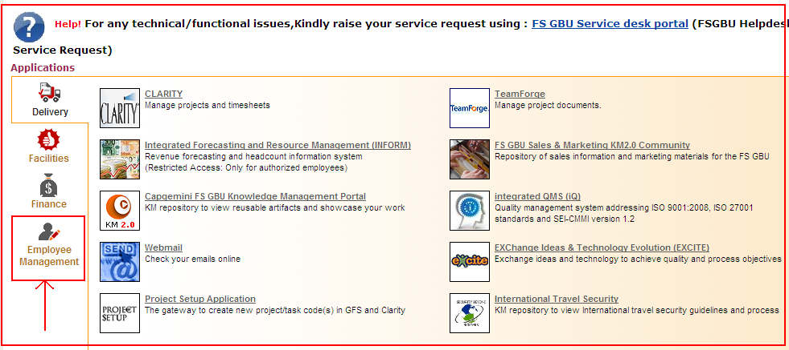

- Click on the Resource Management Group (RMG) Portal link.
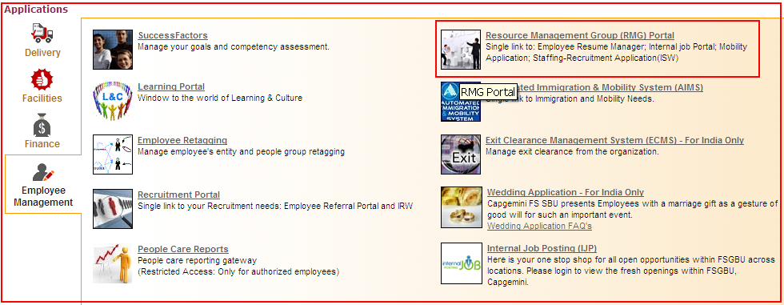

- This will open the RMG portal page. Click on the Integrated Staffing Workflow (ISW) link.
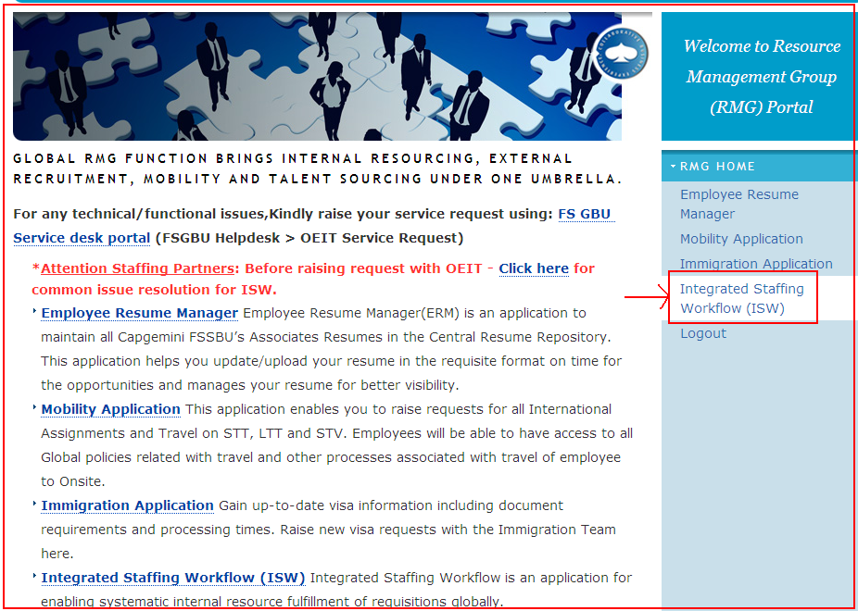
- ISW home page will get opened.
Click on the View allocation details link to see your allocations in ISW.
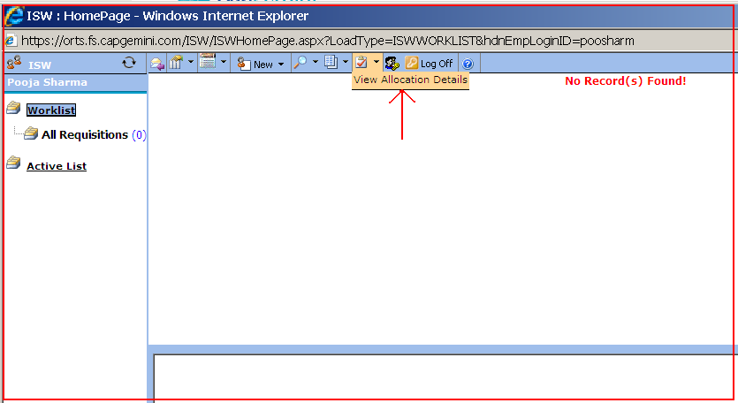

- A new page will be opened with all the allocation history. You can see your allocation details in this page. The current allocation is marked in bold red. Please refer the current allocation details to avoid any auto-rejections in timesheets in clarity.
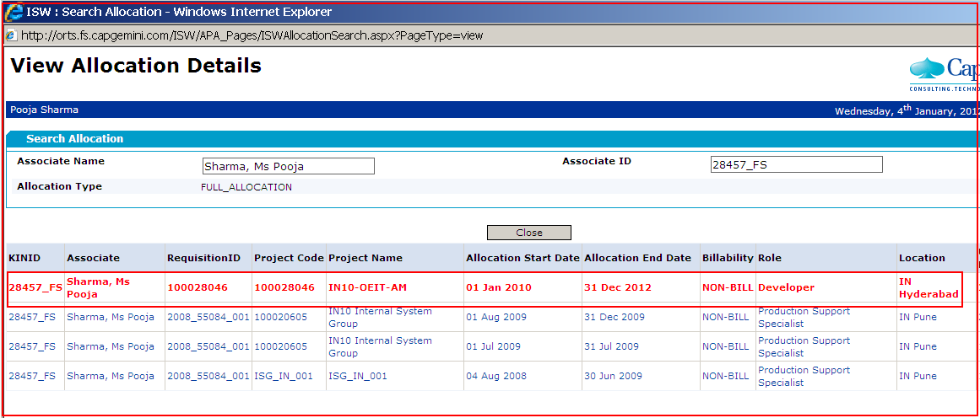

Note: Please refer the allocation details before entering time in clarity. If you are not able to see your current allocation details on this page, then please contact your respective staffing partner.

